DTSC 671: AI Solutions in the Cloud

SUBMISSION TEMPLATE:
Recommendation System Prototype with Amazon Personalize

Select File > Make a copy to edit the template and add your screenshots. Download the completed template as a PDF document to submit to Brightspace.

In every screenshot, include your AWS username that appears in the upper right corner. Example:

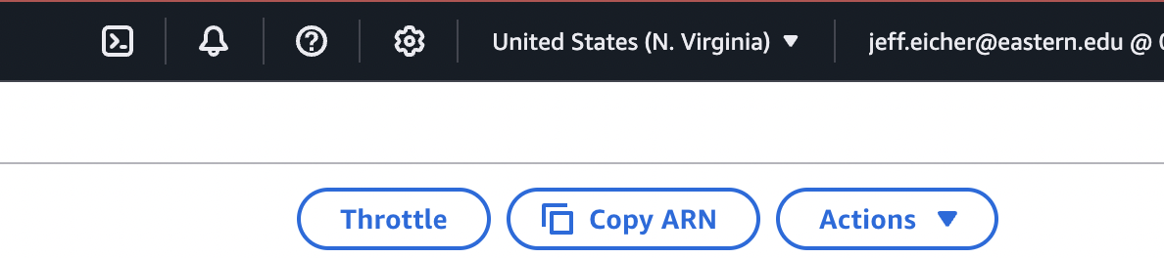

If any one screenshot is missing this identification, the entire assignment will be scored no higher than 70%.

Points totals are provided at the start of each question. You score either full credit or 0 points; there is no partial credit for each question.

Curtis Nielson
DTSC-671

- [20 points] In the space below, provide a screenshot of your dataset group dtsc-671-drink-recs-<yourname> in Amazon Personalize.

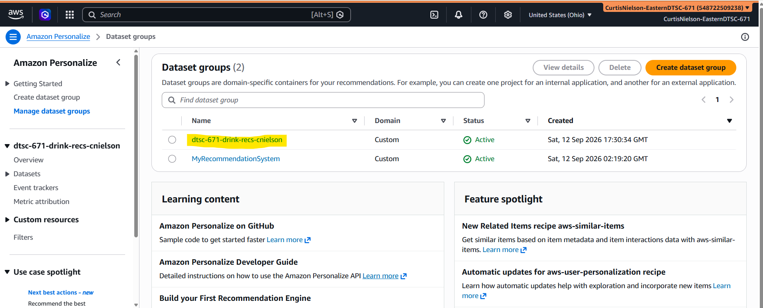
- [30 points] In the space below, provide a screenshot of the active aws-user-personalize-v2 solution.
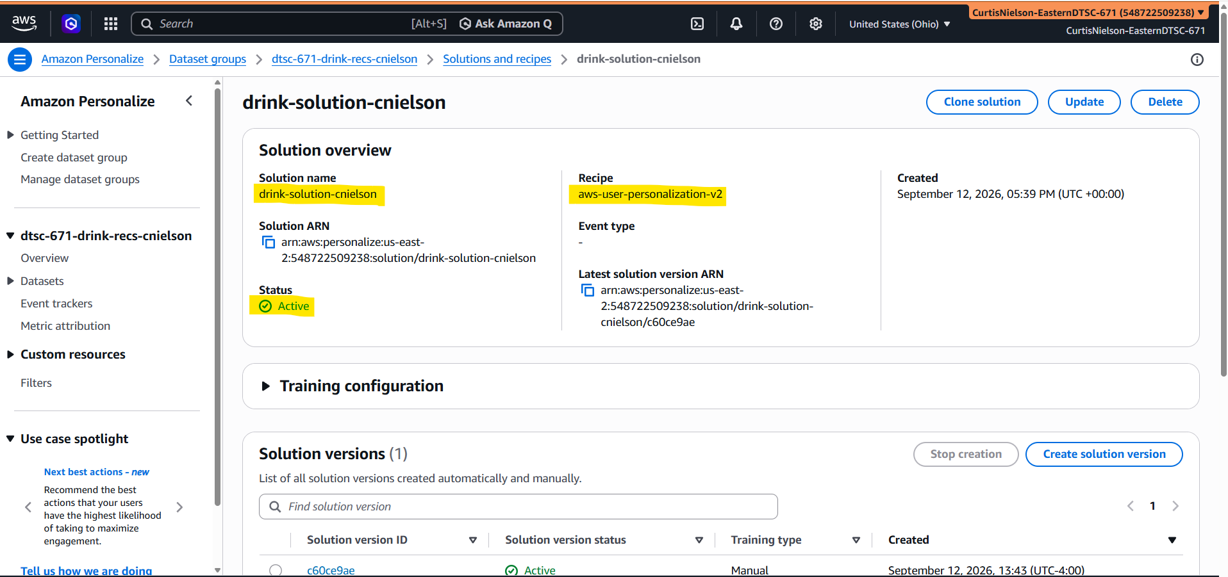
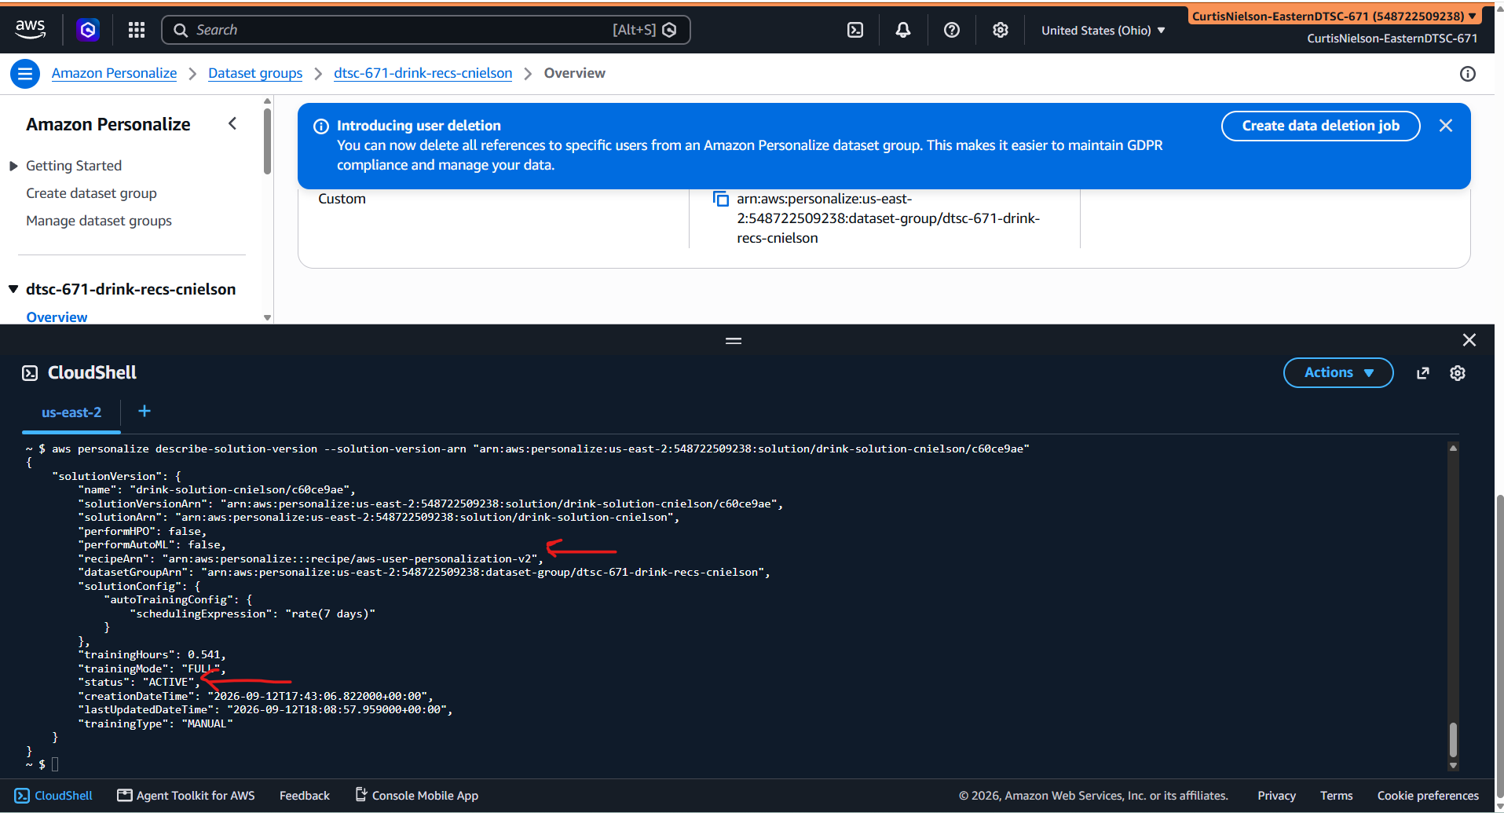

- [50 points] In the space below, provide a screenshot of the test results from the campaign (i.e., the list of recommendations) for customer #80 (i.e., CUST_0080).

